

Final Assignment Part I

STUDENTS:

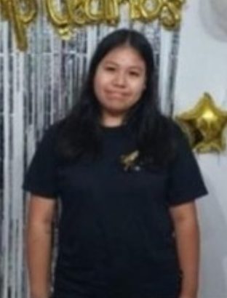
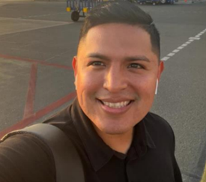
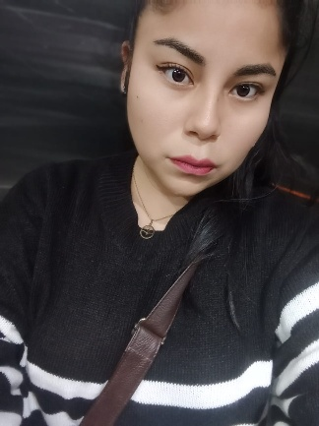

CARHUAS BERNAL, GRESSI ELIZABETH
BENITES CORAZON, MAX ANDERSON
GAVINO COLLANTES, MARIA ALEXANDRA

Dear Cybersecurity Department Manager,
We are writing to apply for a high-level position in the Cybersecurity Department. We are a team of three university students with a strong interest in digital protection and technology. We study careers related to systems, business, and information management, and we have worked together on projects about data security and safe communication.
During our studies, we achieved good results and developed important skills such as teamwork, problem solving, and responsibility. We also have basic experience supporting university events and helping with technical tasks, including assisting users and organizing information. We can work under pressure and learn new tools quickly.
In the future, we are going to specialize in cybersecurity and grow inside the company.
Thank you for your time. You can contact us at cyberteam.group@gmail.com or +51 917 456 890.
Sincerely,
Gressi P., María C. & Max B.

